**Writing code for connecting JDBC to MySQL and execute to display the table?**

**SQL CODE:**

CREATE DATABASE ATM;

USE ATM;

CREATE TABLE ACCOUNT(

NAME VARCHAR(20),

BANK VARCHAR(20),

PIN INT PRIMARY KEY

);

SELECT*FROM ACCOUNT;

**OUTPUT FOR SQL:**

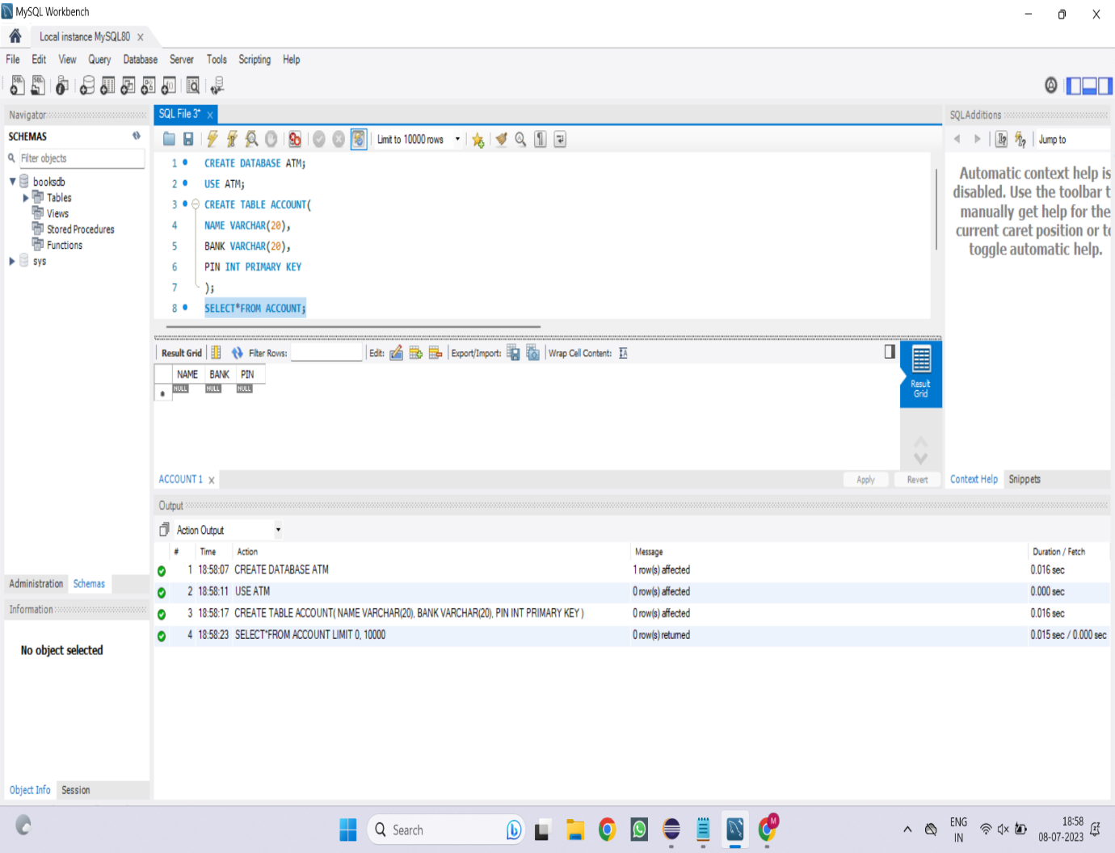

CONNECTIVITY:

package com.jdbc;

import java.sql.Connection;

import java.sql.DriverManager;

import java.sql.ResultSet;

import java.sql.SQLException;

import java.sql.Statement;

public class Main{

public static void main(String args[]) throws ClassNotFoundException, SQLException {

InsertQuery();

selectQuery();

}

static void InsertQuery() throws ClassNotFoundException, SQLException

{

Class.forName("com.mysql.cj.jdbc.Driver");

System.out.println("Driver Class Loaded");

Connection con=DriverManager.getConnection("jdbc:mysql://localhost:3306/ATM","root","Moni@2501");

Statement s=con.createStatement();

int r=s.executeUpdate("INSERT INTO ACCOUNT(NAME,BANK,PIN) VALUES(\"MONI\",\"BOI\",1080);");

System.out.println("Value Inserted");

}

static void selectQuery() throws ClassNotFoundException, SQLException {

Class.forName("com.mysql.cj.jdbc.Driver");

System.out.println("Driver Class Loaded");

Connection con=DriverManager.getConnection("jdbc:mysql://localhost:3306/ATM","root","Moni@2501");

Statement s=con.createStatement();

ResultSet rs=s.executeQuery("SELECT*FROM ATM.ACCOUNT;");

while(rs.next()) {

System.out.println(rs.getString("NAME")+" "+rs.getString("BANK")+" "+rs.getString("PIN"));

}

}

}

**OUTPUT:**

